实 验 报 告

辽宁科技大学软件学院（系） 2023年04月12日
课名：Java框架SpringMVC |  | 实验项目名称：依赖注入的类型
班级：软件204 | 姓名： 于有为 |  | 学号：120203504005 | 任课教师：杨松波
实验目的：
- 掌握依赖注入的构造方法注入
- 掌握依赖注入的setter方法注入

实验内容：
构造方法注入:
package dao;
public interface TestDIDao {
public void sayHello();
}

package dao;
public class TestDIDaoImpl implements TestDIDao {
@Override
public void sayHello() {
// TODO Auto-generated method stub
System.out.println("TestDIDaoImpl is speaking...");
}
}

package service;
public interface TestDIService {
public void sayHello();
}

package service;
import dao.TestDIDao;
public class TestDIServiceImpl implements TestDIService {
private TestDIDao testDIDao;
public TestDIServiceImpl(TestDIDao testDIDao) {
super();
this.testDIDao = testDIDao;
}
@Override
public void sayHello() {
// TODO Auto-generated method stub
testDIDao.sayHello();
System.out.println("TestDIService构造方法注入say：Hello,Study Hard!");
}
}

<?xml version="1.0" encoding="UTF-8"?>
<beans xmlns="http://www.springframework.org/schema/beans"
xmlns:xsi="http://www.w3.org/2001/XMLSchema-instance"
xsi:schemaLocation="http://www.springframework.org/schema/beans
http://www.springframework.org/schema/beans/spring-beans.xsd">
<!-- 将指定类TestDaoImpl配置给Spring，让Spring创建其实例 -->
<bean id="myTestDIDao" class="dao.TestDIDaoImpl"/>
<bean id="testDIService" class="service.TestDIServiceImpl">
<constructor-arg index="0" ref="myTestDIDao"/>
</bean>
</beans>

package test;
import org.springframework.context.ApplicationContext;
import org.springframework.context.support.ClassPathXmlApplicationContext;
import service.TestDIService;
public class Test {
public static void main(String[] args) {
// TODO Auto-generated method stub
ApplicationContext appCon=new ClassPathXmlApplicationContext("applicationContext.xml");
TestDIService ts=(TestDIService)appCon.getBean("testDIService");
ts.sayHello();
}
}

setter方法注入
package dao;
public interface TestDIDao {
public void sayHello();
}

package dao;
public class TestDIDaoImpl implements TestDIDao {
@Override
public void sayHello() {
// TODO Auto-generated method stub
System.out.println("TestDIDaoImpl is speaking...");
}
}

package service;
public interface TestDIService {
public void sayHello();
}

package service;
import dao.TestDIDao;
public class TestDIServiceImpl implements TestDIService {
private TestDIDao testDIDao;
public void setTestDIDao(TestDIDao testDIDao) {
this.testDIDao = testDIDao;
}

@Override
public void sayHello() {
// TODO Auto-generated method stub
testDIDao.sayHello();
System.out.println("TestDIService setter方法注入say：Hello,Study Hard!");
}

}

<?xml version="1.0" encoding="UTF-8"?>
<beans xmlns="http://www.springframework.org/schema/beans"
xmlns:xsi="http://www.w3.org/2001/XMLSchema-instance"
xsi:schemaLocation="http://www.springframework.org/schema/beans
http://www.springframework.org/schema/beans/spring-beans.xsd">
<!-- 将指定类TestDaoImpl配置给Spring，让Spring创建其实例 -->
<bean id="myTestDIDao" class="dao.TestDIDaoImpl"/>
<bean id="testDIService" class="service.TestDIServiceImpl">
<property name="testDIDao" ref="myTestDIDao"/>
</bean>
</beans>

package test;
import org.springframework.context.ApplicationContext;
import org.springframework.context.support.ClassPathXmlApplicationContext;
import service.TestDIService;
public class Test {
public static void main(String[] args) {
// TODO Auto-generated method stub
ApplicationContext appCon=new ClassPathXmlApplicationContext("applicationContext.xml");
TestDIService ts=(TestDIService)appCon.getBean("testDIService");
ts.sayHello();
}
}

实验结果及思考题分析：
- 构造方法注入：
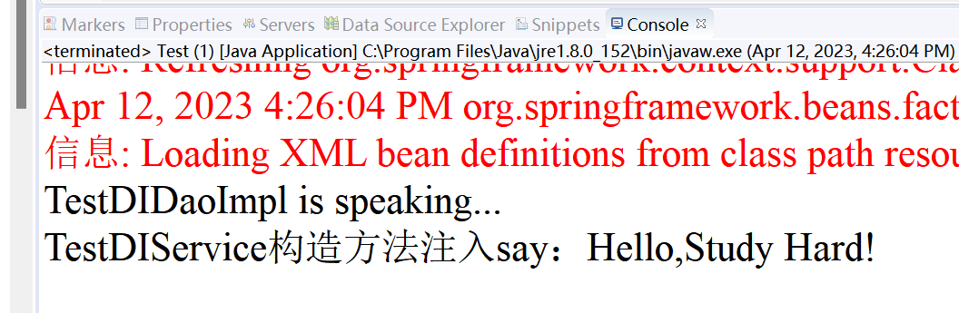
- Setter方法注入：
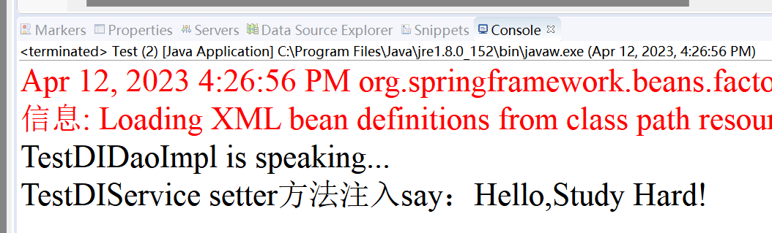
心得体会：
通过这次实验，学习了spring的两种属性注入，Spring的两种依赖注入方式：setter注入与构造方法注入，这两种方法的不同主要就是在xml文件下对应使用property和constructor-arg属性。
评语：

